***DSP LAB***

***Experiment 1 (PLOTTING)***

x = [0:0.1:10];

y = sin (x);

z = cos (x);

subplot (3,1,1);

plot (x,y);

grid on;

subplot (3,1,2);

plot (x,z);

grid on;

hold on;

subplot (3,1,3);

stem (x,z);

grid on;

hold on;

subplot (3,1,3);

stem (x,y, ,'r');

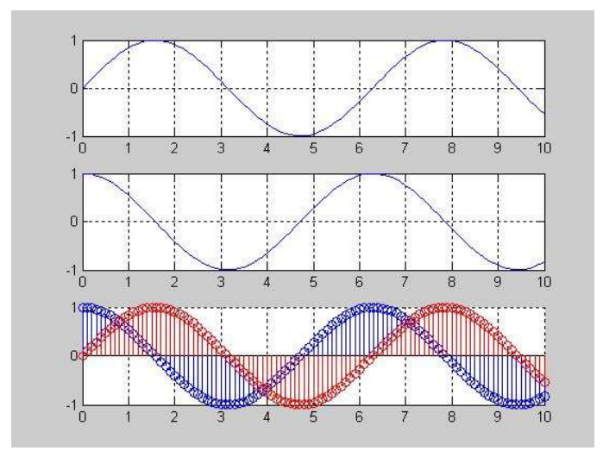

***Experiment 2 (Generating a Signal)***

Generation of Signals (Sinusoidal Sequence)

% Generation of sinusoidal signals

% 2sin(2πτ-π/2)

T = [-5:0.01:5];

x=2*sin((2*pi*t) - (pi/2));

plot(t,x)

grid on;

axis ([-6 6 -3 3])

ylabel ('x(t)')

xlabel ('Time(sec)')

title ('Figure 2.1')

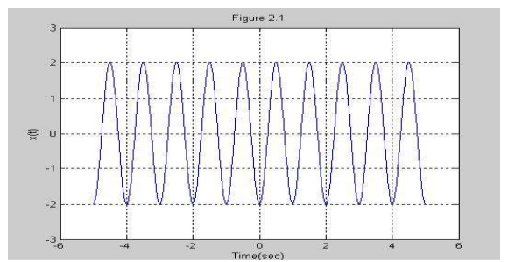

***Experiment 3 (Generating a Signal)***

% Generation of discrete time signals

% 2sin(2πτ-π/2)

T = [-5:0.01:5];

x=2*sin((2*pi*t) - (pi/2));

plot(t,x)

grid on;

axis ([-6 6 -3 3])

ylabel ('x(t)')

xlabel ('Time(sec)')

title ('Figure 2.1')

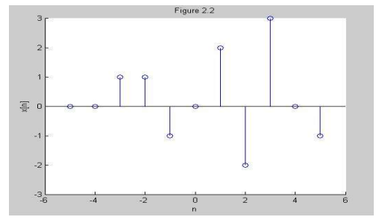

***Experiment 4 (Generating a Signal)***

%Generation of random sequence

n = [0:10];

x = rand (1, length (n));

y = randn (1, length (n));

plot (n,x) ;

grid on;

hold on;

plot(n,y,'r');

ylabel ('x & y')

xlabel ('n')

title ('Figure 2.3');

